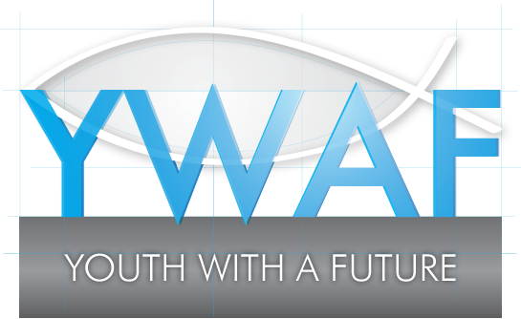 GRANTS FOR COMMUNITY GROUPS
YWAF works with a Christian ethos to support young people aged 16-25 in the Mendip area of Somerset. Please refer to the funding guidelines and fill the application form in as best as you can, so that we assess your request more easily.
Name of Community Group

Charity number (if registered charity):

Contact name & position | Address & email address | Tel no

What are you asking for funding for?

What is this going to help you to achieve?

How much is this going to cost?

How much are you asking for, and how much can you contribute yourself? (YWAF receive lots of requests, so we can look more favourably on requests if you try to fund part of it yourself!)

We ask that after you have achieved your goal, you let us know about your achievements, either by letter or email. With your permission we would like to put them on our web site, to celebrate your success (although we will not use your name for this, as we respect your privacy)

Are you ok with this? …................. When could you let us know by? .........................................

Signed........................................................................................... Date ……………………………….

If application is successful, please give details of bank account into which we would pay your grant:
Account name ………………………………………………………… Bank: ……………………………………………………….
Sort Code ………………………………………………… Account number ……………………………………………………….

